

CS-250: Lab 04
Runtime Complexity Analysis

Muhammad Mujtaba
CMD ID: 540040
mmujtaba.bese25seecs@seecs.edu.pk

  - Class: BESE 16B
  - Batch: 2k25

Task 1:
Time Harness:
#include <chrono>
#include <print>

int main()
{
int arr[] = {1, 2, 3, 4, 5, 6, 7, 8, 9, 10};

std::chrono::time_point start = std::chrono::steady_clock::now();

////////CODE////CODE////CODE////CODE////CODE////CODE////CODE////////
////CODE////CODE////CODE////CODE////CODE////CODE////CODE////CODE////
////////CODE////CODE////CODE////CODE////CODE////CODE////CODE////////

std::chrono::time_point end = std::chrono::steady_clock::now();

auto timeInUs = std::chrono::duration_cast<std::chrono::microseconds>(end - start);
auto timeInMs = std::chrono::duration_cast<std::chrono::milliseconds>(end - start);

std::println("Time For Program: {} ≈ {}", timeInUs, timeInMs);

return 0;
}

Code | Complexity | Reason
A | O(1) | Equivalent to resolving a pointer address with pointer arithmetic.
B | O(N) | Looping over each element once.
C | O(N²) | Nested for loops, with inner one looping over the elements again.
D | O(N) | Linearly scales with the number of elements in the linked list.

Screenshots of runtime
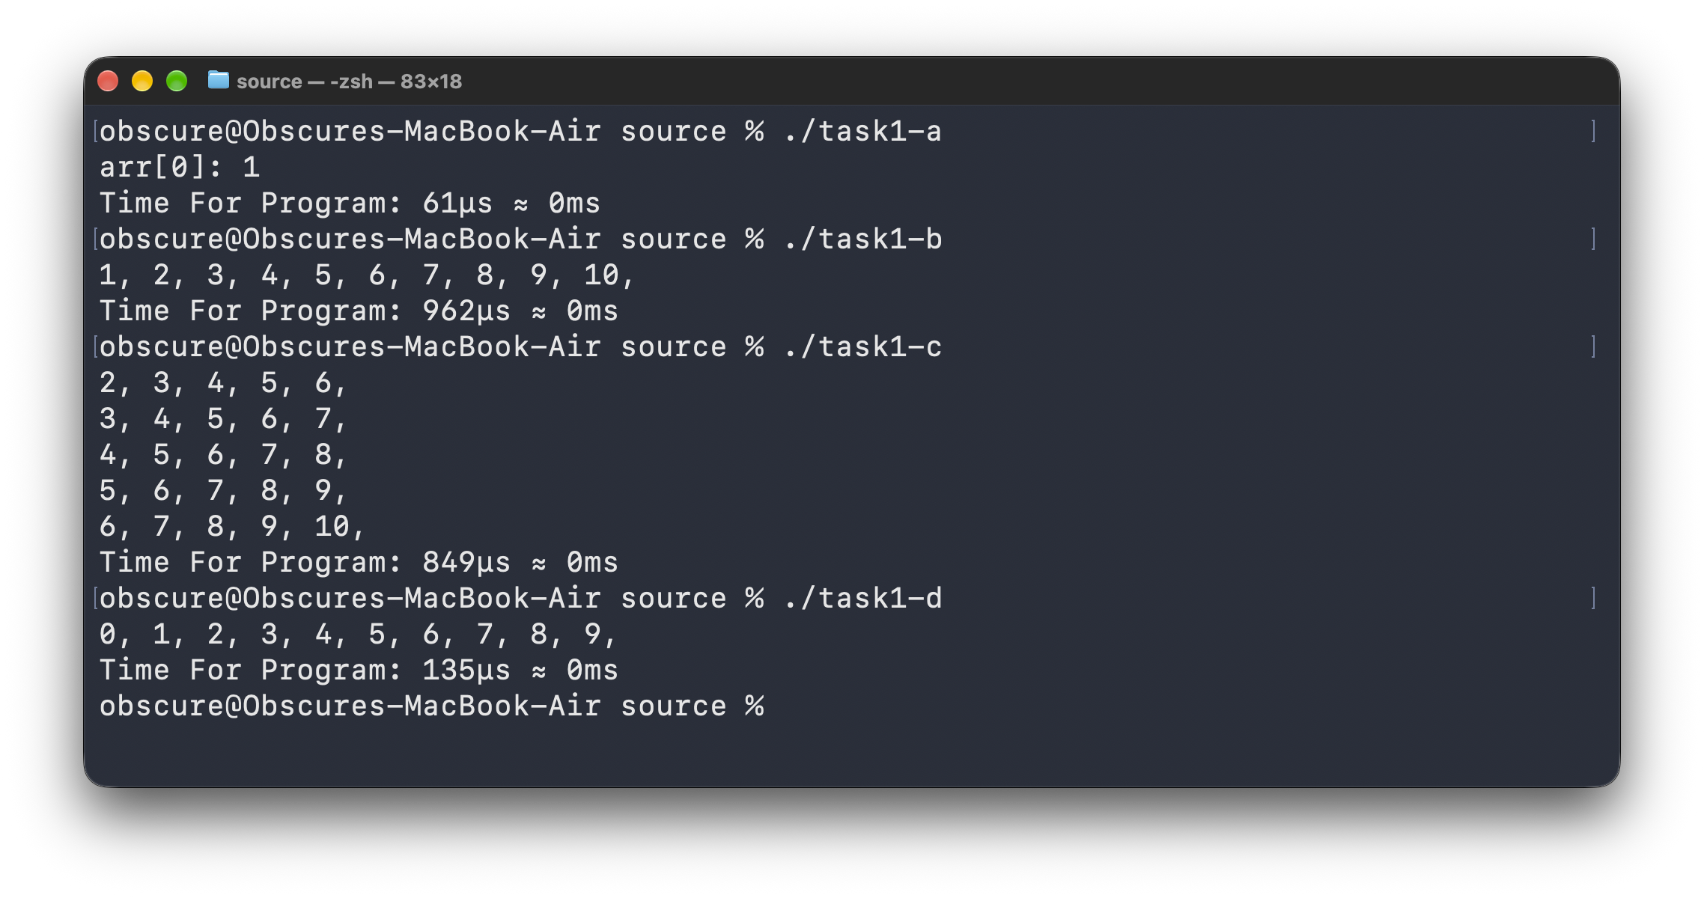

Task 2:
#include <chrono>
#include <print>
#include <random>
#include <optional>

#include "linked_list.hpp"

struct ParsedArgs
{
int n = 10;
};

bool parseArgs(int argc, char *argv[], ParsedArgs *returnValue)
{
if (argc < 2)
return false;

try
{
returnValue->n = std::stoi(argv[1]);
return true;
}
catch (const std::exception &)
{
return false;
}
}

#define SHOW_TIME(FUNC) \
do \
{ \
std::chrono::time_point start = std::chrono::steady_clock::now(); \
FUNC \
std::chrono::time_point end = std::chrono::steady_clock::now(); \
auto timeInUs = std::chrono::duration_cast<std::chrono::microseconds>(end - start); \
auto timeInMs = std::chrono::duration_cast<std::chrono::milliseconds>(end - start); \
std::println("Time For Program: {} ≈ {}", timeInUs, timeInMs); \
} while (0);

int main(int argc, char *argv[])
{
ParsedArgs args;
parseArgs(argc, argv, &args);

LinkedList myLinkedList{};
for (size_t i = 0; i < args.n; i++)
{
myLinkedList.insertAt(std::rand() % 20, 0);
}

SHOW_TIME(
int index = 0;
size_t nodes_examined = 0;
std::println("@index{{{}}}: {}; visited {} nodes", index, *myLinkedList.get(index, &nodes_examined), nodes_examined); //
);

SHOW_TIME(
int index = myLinkedList.count() / 2;
size_t nodes_examined = 0;
std::println("@index{{{}}}: {}; visited {} nodes", index, *myLinkedList.get(index, &nodes_examined), nodes_examined); //
);

SHOW_TIME(
int index = myLinkedList.count() - 1;
size_t nodes_examined = 0;
std::println("@index{{{}}}: {}; visited {} nodes", index, *myLinkedList.get(index, &nodes_examined), nodes_examined); //
);

return 0;
}

 | First |  |  | Middle |  |  | Last
N | Big-O | Visits | Time | Big-O | Visits | Time | Big-O | Visits | Time
100 | O(1) | 1 | 68μs | O(N) | 51 | 9μs | O(N) | 100 | 9μs
1,000 | O(1) | 1 | 54μs | O(N) | 501 | 30μs | O(N) | 1,000 | 43μs
10,000 | O(1) | 1 | 74μs | O(N) | 5,001 | 178μs | O(N) | 10,000 | 322μs
100,000 | O(1) | 1 | 77μs | O(N) | 50,001 | 917μs | O(N) | 100,000 | 1818μs

Note: The reason the first access time are sometimes larger is due to data not being loaded into cache etc. Furthermore, calculations at microseconds scale can lead to noise. Time for println functions was also included in recorded time as well.

Screenshots of runtime
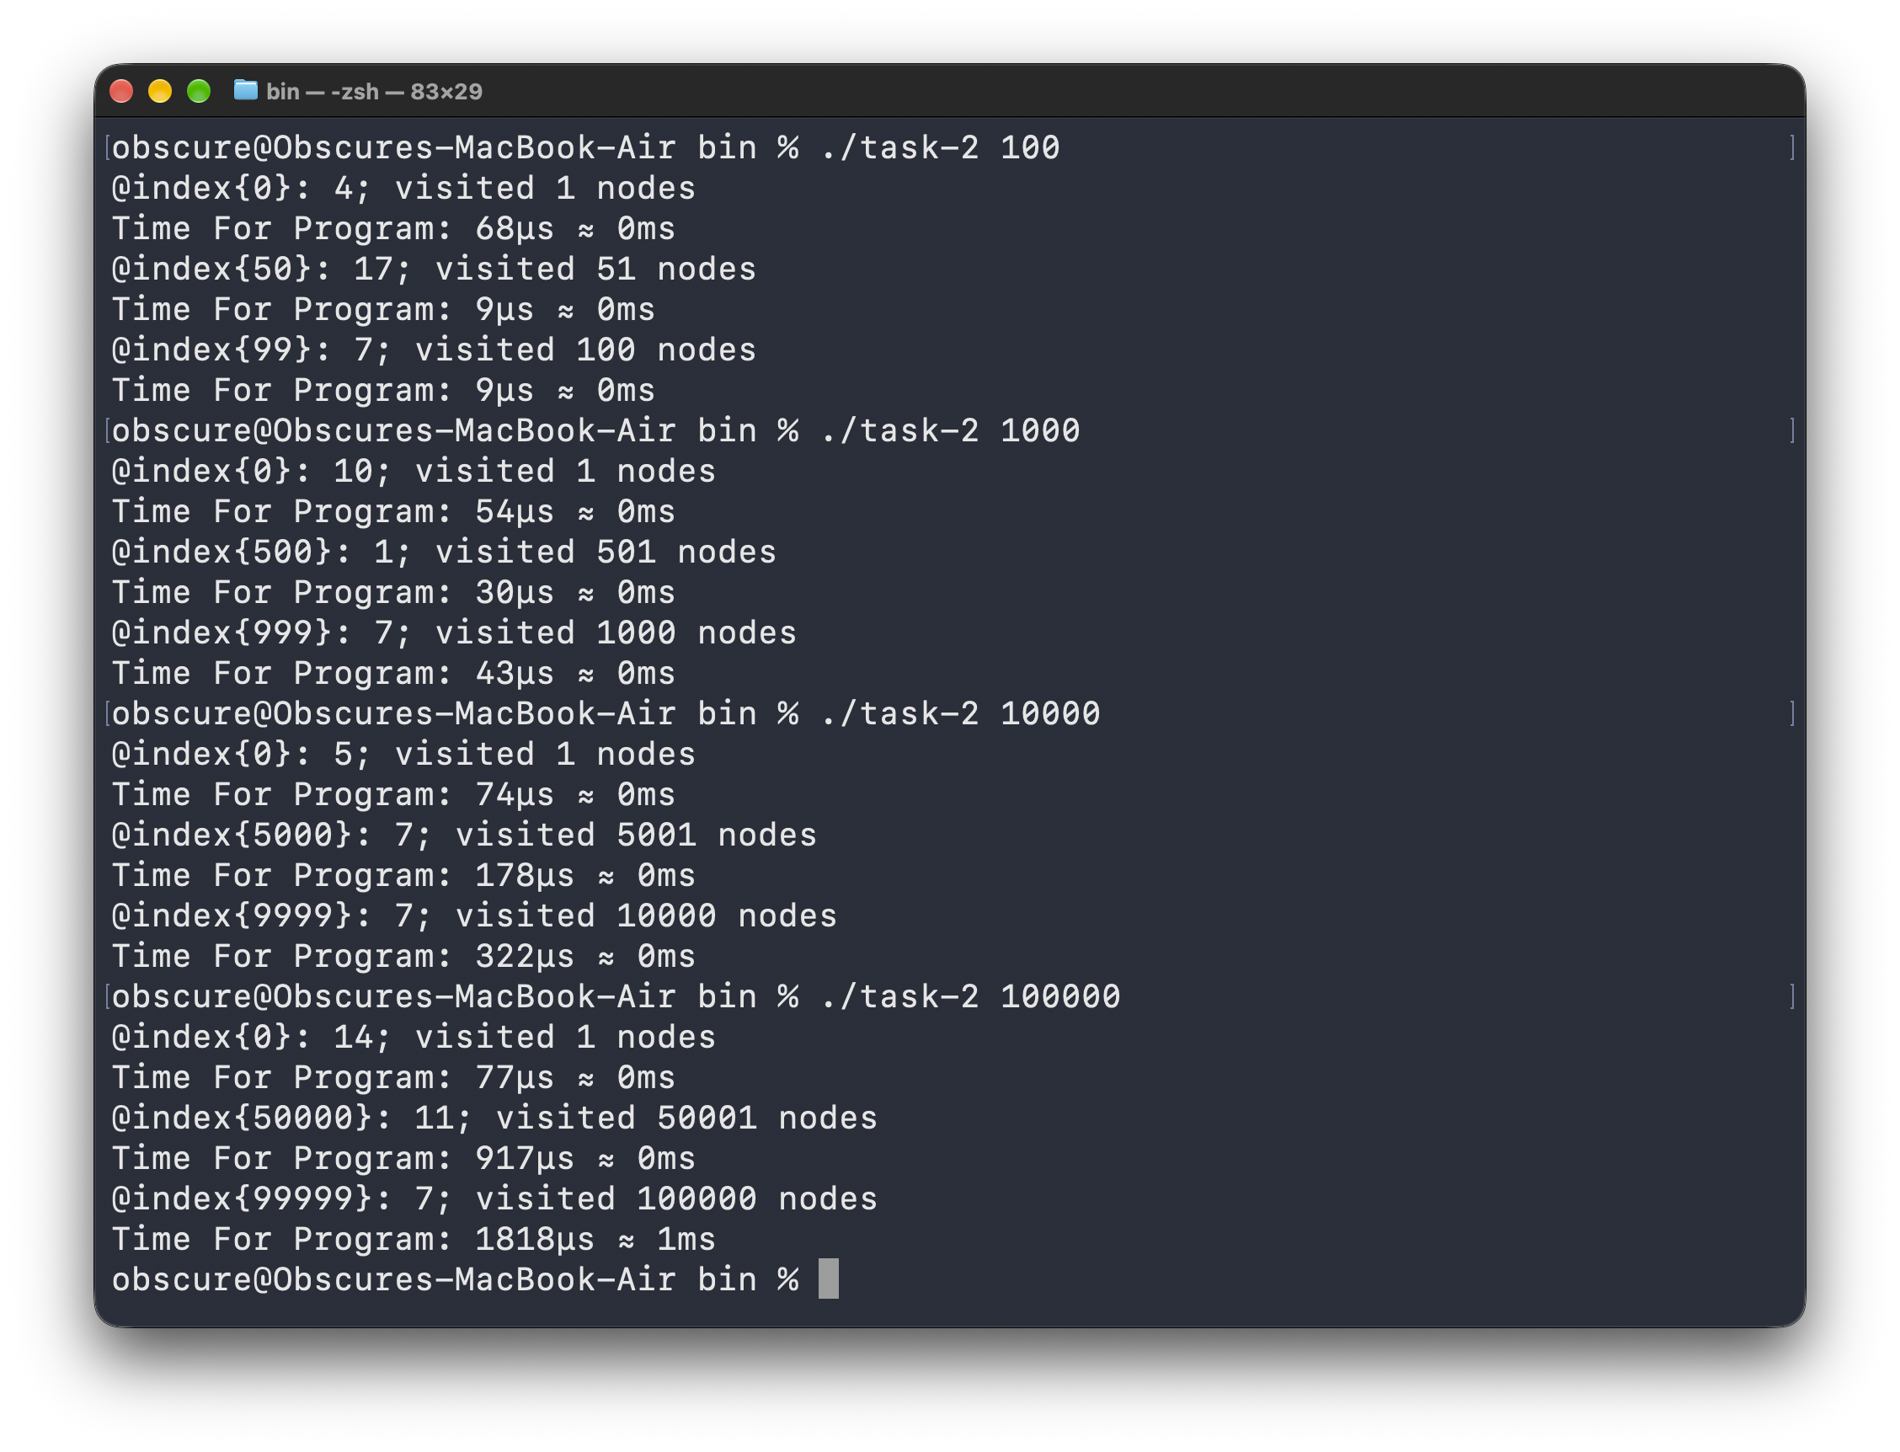

Task 3:
#include <chrono>
#include <cstdlib>
#include <ctime>
#include <print>
#include <string>

#include "linked_list.hpp"

constexpr size_t N = 100'000;

void accessFirst(int *array, LinkedList &list);
void accessLast(int *array, LinkedList &list);
void accessRandom(int *array, LinkedList &list);
void findValue(int *array, LinkedList &list, int value);

#define SHOW_TIME(FUNC) \
do \
{ \
std::chrono::time_point start = std::chrono::steady_clock::now(); \
FUNC \
std::chrono::time_point end = std::chrono::steady_clock::now(); \
auto timeInUs = std::chrono::duration_cast<std::chrono::microseconds>(end - start); \
auto timeInMs = std::chrono::duration_cast<std::chrono::milliseconds>(end - start); \
std::println("Time For Program: {} ≈ {}", timeInUs, timeInMs); \
} while (0);

int main(int argc, char *argv[])
{
if (argc < 2)
{
std::println("Usage: ./task-3 --first | --last | --random | --find <value>");
return 1;
}

// seed rand
std::srand(static_cast<unsigned int>(std::time(nullptr)));

int *array = new int[N];
LinkedList list{};

for (size_t i = N; i > 0; i--)
{
const int value = std::rand() % 20;
array[i - 1] = value;
// list inserts in reverse order
// 4, 3, 2, 1
list.insertStart(value);
}

std::string operation = argv[1];

if (operation == "--first")
accessFirst(array, list);
else if (operation == "--last")
accessLast(array, list);
else if (operation == "--random")
accessRandom(array, list);
else if (operation == "--find" && argc >= 3)
findValue(array, list, std::atoi(argv[2]));
else
std::println("Invalid arguments");

delete[] array;
return 0;
}

void accessFirst(int *array, LinkedList &list)
{
SHOW_TIME(
std::println("Dynamic Array:");
int value = array[0];
std::println("Value: {}", value); //
);

SHOW_TIME(
size_t examined = 0;
int value = *list.get(0, &examined);
std::println("Singly Linked List:");
std::println("Value: {}; visited {} nodes", value, examined); //
);
}

void accessLast(int *array, LinkedList &list)
{
SHOW_TIME(
std::println("Dynamic Array:");
int value = array[N - 1];
std::println("Value: {}", value); //
);

SHOW_TIME(
size_t examined = 0;
int value = *list.get(N - 1, &examined);
std::println("Singly Linked List:");
std::println("Value: {}; visited {} nodes", value, examined); //
);
}

void accessRandom(int *array, LinkedList &list)
{
size_t index = std::rand() % N;

SHOW_TIME(
std::println("Dynamic Array:");
int value = array[index];
std::println("Value: {}", value); //
);

SHOW_TIME(
size_t examined = 0;
int value = *list.get(index, &examined);
std::println("Singly Linked List:");
std::println("Value: {}; visited {} nodes", value, examined); //
);
}

void findValue(int *array, LinkedList &list, int value)
{

SHOW_TIME(
int arrayIndex = -1;
std::println("Dynamic Array:");
for (size_t i = 0; i < N; i++) {
if (array[i] == value)
{
arrayIndex = static_cast<int>(i);
break;
}
} //
std::println("Found {} at index {}", value, arrayIndex); //
);

SHOW_TIME(
int listIndex = -1;
std::println("Singly Linked List:");
list.forEach([&](ConstNode node, size_t index) { //
if (node->data == value)
{
listIndex = static_cast<int>(index);
return true;
}
return false;
});
std::println("Found {} at index {}", value, listIndex); //
);
}

void accessFirst(int *array, LinkedList &list)
{
SHOW_TIME(
std::println("Dynamic Array:");
int value = array[0];
std::println("Value: {}", value); //
);

SHOW_TIME(
size_t examined = 0;
int value = *list.get(0, &examined);
std::println("Singly Linked List:");
std::println("Value: {}; visited {} nodes", value, examined); //
);
}

void accessLast(int *array, LinkedList &list)
{
SHOW_TIME(
std::println("Dynamic Array:");
int value = array[N - 1];
std::println("Value: {}", value); //
);

SHOW_TIME(
size_t examined = 0;
int value = *list.get(N - 1, &examined);
std::println("Singly Linked List:");
std::println("Value: {}; visited {} nodes", value, examined); //
);
}

void accessRandom(int *array, LinkedList &list)
{
size_t index = std::rand() % N;

SHOW_TIME(
std::println("Dynamic Array:");
int value = array[index];
std::println("Value: {}", value); //
);

SHOW_TIME(
size_t examined = 0;
int value = *list.get(index, &examined);
std::println("Singly Linked List:");
std::println("Value: {}; visited {} nodes", value, examined); //
);
}

void findValue(int *array, LinkedList &list, int value)
{

SHOW_TIME(
int arrayIndex = -1;
std::println("Dynamic Array:");
for (size_t i = 0; i < N; i++) {
if (array[i] == value)
{
arrayIndex = static_cast<int>(i);
break;
}
} //
std::println("Found {} at index {}", value, arrayIndex); //
);

SHOW_TIME(
int listIndex = -1;
std::println("Singly Linked List:");
list.forEach([&](ConstNode node, size_t index) { //
if (node->data == value)
{
listIndex = static_cast<int>(index);
return true;
}
return false;
});
std::println("Found {} at index {}", value, listIndex); //
);
}

 | Dynamic Array |  | Linked List
Operation | Complexity | Time | Complexity | Time
First | O(1) | 64μs | O(1) | 16μs
Random | O(1) | 57μs | O(N) | 1586μs
Last | O(1) | 85μs | O(N) | 1644μs
Find | O(N) | 69μs | O(N) | 12μs

Note: The reason the first access time are sometimes larger is due to data not being loaded into cache etc. Furthermore, calculations at microseconds scale can lead to noise. Time for println functions was also included in recorded time as well.

Screenshots of runtime
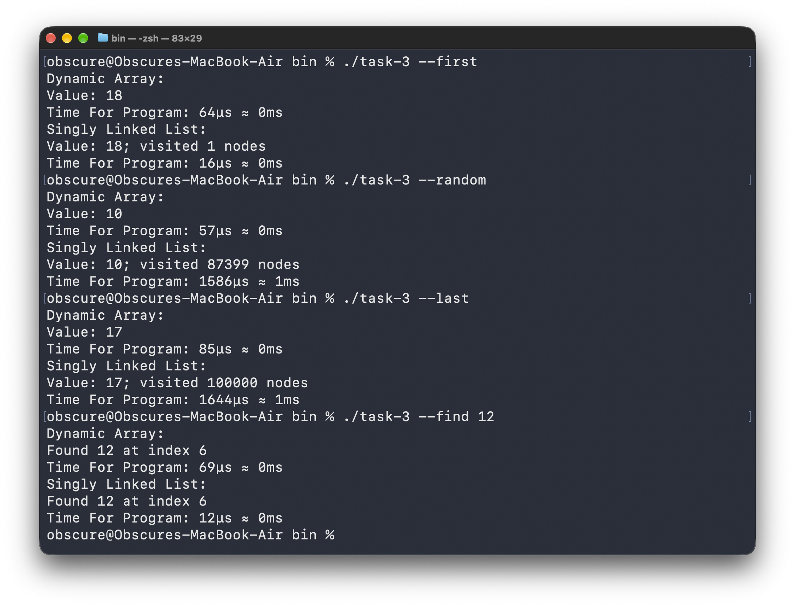

Task 4:
#include <chrono>
#include <cstdlib>
#include <ctime>
#include <print>

#include "linked_list.hpp"

constexpr size_t N = 100'000;

#define SHOW_TIME(FUNC) \
do \
{ \
std::chrono::time_point start = std::chrono::steady_clock::now(); \
FUNC \
std::chrono::time_point end = std::chrono::steady_clock::now(); \
auto timeInUs = std::chrono::duration_cast<std::chrono::microseconds>(end - start); \
auto timeInMs = std::chrono::duration_cast<std::chrono::milliseconds>(end - start); \
std::println("Time For Program: {} ≈ {}", timeInUs, timeInMs); \
} while (0);

int main()
{
std::srand(static_cast<unsigned int>(std::time(nullptr)));

LinkedList headOnlyList{};
LinkedList pointerList{};

for (size_t i = 0; i < N; i++)
{
const int value = std::rand() % 20;
headOnlyList.insertStart(value);
pointerList.insertStart(value);
}

SHOW_TIME(
std::println("Delete last node using only head:");
headOnlyList.removeLast(); //
);

// get pointers
Node *previous = nullptr;
Node *target = nullptr;
pointerList.forEach([&](NodeLink current, size_t index) { //
if (index == N - 2)
previous = current;

if (index == N - 1)
{
target = current;
return true;
}

return false;
});

SHOW_TIME(
std::println("Delete node with previous and target pointers:");
previous->next = target->next;
delete target; //
);

return 0;
}

 | Linked List
Operation | Complexity | Time
Traversal | O(N) | 2910μs
Pointer | O(1) | 8μs

Screenshots of runtime
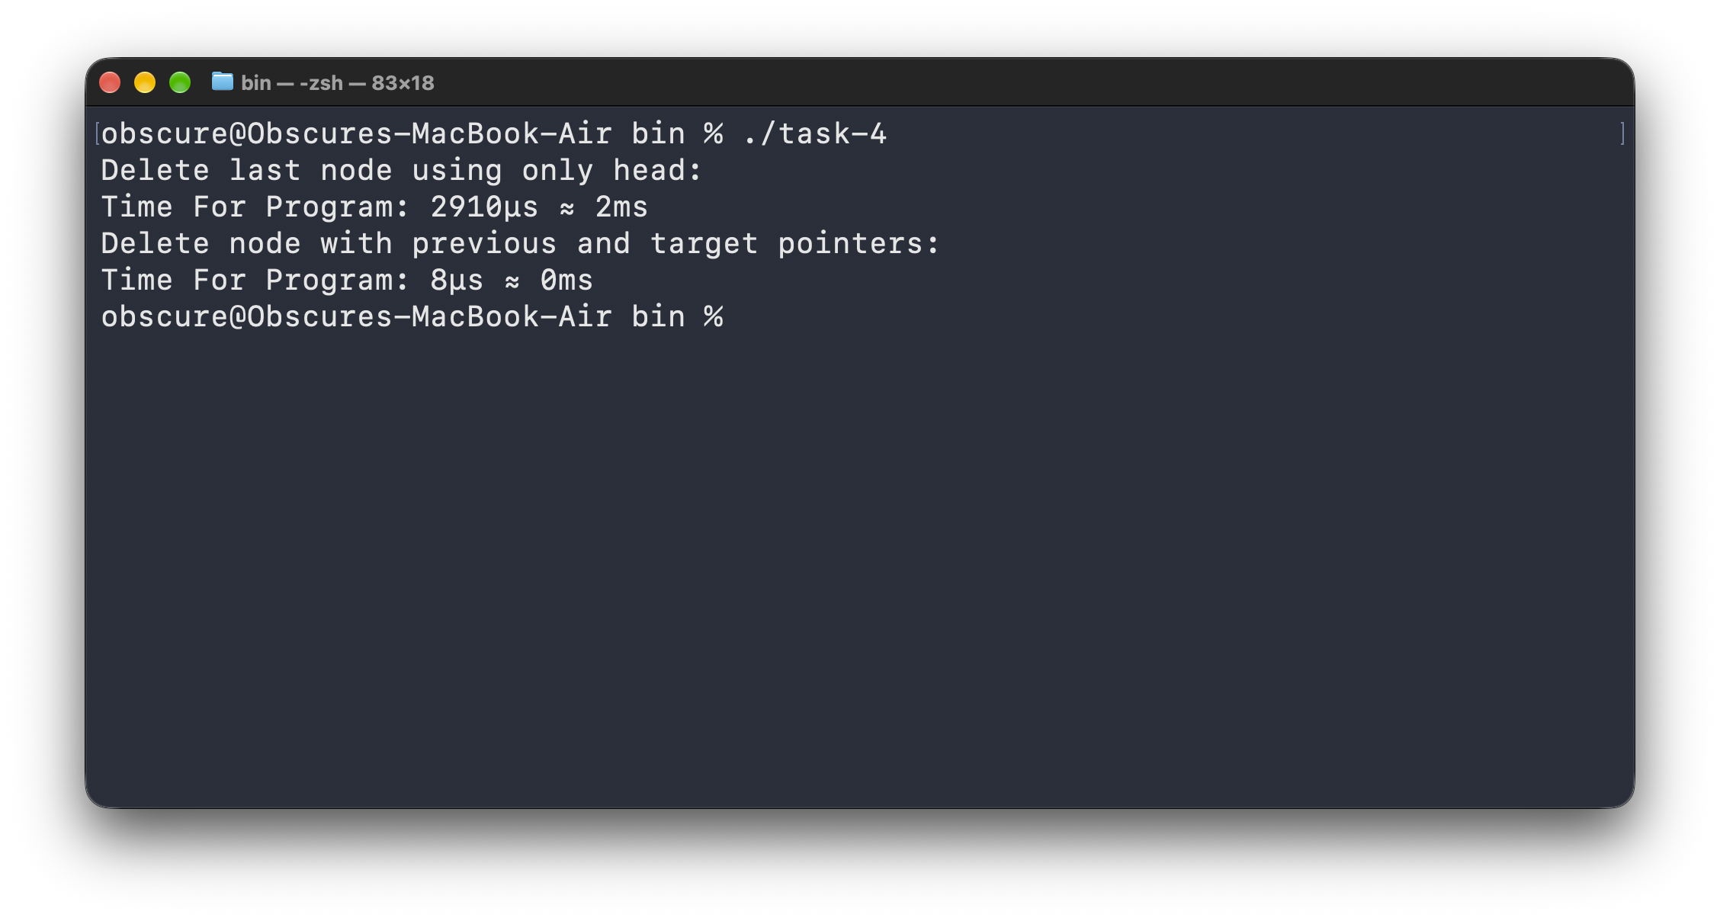

Task 5:
#include <chrono>
#include <cstdlib>
#include <ctime>
#include <print>
#include <string>

#include "linked_list.hpp"
#include "doubly_linked_list.hpp"

constexpr size_t N = 100'000;

void runSingly(LinkedList &list);
void runDoubly(DoublyLinkedList &list);

#define SHOW_TIME(...) \
do \
{ \
std::chrono::time_point start = std::chrono::steady_clock::now(); \
__VA_ARGS__ \
std::chrono::time_point end = std::chrono::steady_clock::now(); \
auto timeInUs = std::chrono::duration_cast<std::chrono::microseconds>(end - start); \
auto timeInMs = std::chrono::duration_cast<std::chrono::milliseconds>(end - start); \
std::println("Time For Program: {} ≈ {}", timeInUs, timeInMs); \
} while (0);

int main(int argc, char *argv[])
{
if (argc < 2)
{
std::println("Usage: ./main --singly | --doubly");
return 1;
}

std::srand(static_cast<unsigned int>(std::time(nullptr)));

LinkedList singly{};
DoublyLinkedList doubly{};

// same random integers in both lists
for (size_t i = 0; i < N; i++)
{
const int value = std::rand() % 20;
singly.insertStart(value);
doubly.insertStart(value);
}

const std::string type = argv[1];

if (type == "--singly")
runSingly(singly);
else if (type == "--doubly")
runDoubly(doubly);
else
{
std::println("Usage: ./main --singly | --doubly");
return 1;
}

return 0;
}

void runSingly(LinkedList &list)
{
Node *head = nullptr;
Node *current = nullptr;

// current pointer is already available before timing
list.forEach([&](NodeLink node, size_t index) { //
if (index == 0)
head = node;

if (index == N / 2)
{
current = node;
return true;
}

return false;
});

SHOW_TIME(
Node *next = current->next;
std::println("Next: {}", next->data); //
);

SHOW_TIME(
Node *previous = head;

while (previous->next != current)
previous = previous->next;

std::println("Previous: {}", previous->data); //
);

const int insertAfterValue = std::rand() % 20;

SHOW_TIME(
Node *newNode = new Node{insertAfterValue, current->next};
current->next = newNode;
std::println("Inserted After: {}", insertAfterValue); //
);

const int insertBeforeValue = std::rand() % 20;

SHOW_TIME(
Node *previous = head;

while (previous->next != current)
previous = previous->next;

previous->next = new Node{insertBeforeValue, current};
std::println("Inserted Before: {}", insertBeforeValue); //
);

SHOW_TIME(
Node *previous = head;

while (previous->next != current)
previous = previous->next;

previous->next = current->next;
delete current;
current = nullptr;

std::println("Deleted"); //
);
}

void runDoubly(DoublyLinkedList &list)
{
DoubleSidedNode *current = nullptr;

// current pointer is already available before timing
list.forEach([&](DoubleSidedNodeLink node, size_t index) { //
if (index == N / 2)
{
current = node;
return true;
}

return false;
});

SHOW_TIME(
DoubleSidedNode *next = current->next;
std::println("Next: {}", next->data); //
);

SHOW_TIME(
DoubleSidedNode *previous = current->previous;
std::println("Previous: {}", previous->data); //
);

const int insertAfterValue = std::rand() % 20;

SHOW_TIME(
DoubleSidedNode *newNode = new DoubleSidedNode{
insertAfterValue,
current,
current->next};

if (current->next != nullptr) current->next->previous = newNode;

current->next = newNode;

std::println("Inserted After: {}", insertAfterValue); //
);

const int insertBeforeValue = std::rand() % 20;

SHOW_TIME(
DoubleSidedNode *newNode = new DoubleSidedNode{
insertBeforeValue,
current->previous,
current};

current->previous->next = newNode; current->previous = newNode;

std::println("Inserted Before: {}", insertBeforeValue); //
);

SHOW_TIME(
current->previous->next = current->next;

if (current->next != nullptr)
current->next->previous = current->previous;

delete current;
current = nullptr;

std::println("Deleted"); //
);
}

void runSingly(LinkedList &list)
{
Node *head = nullptr;
Node *current = nullptr;

// current pointer is already available before timing
list.forEach([&](NodeLink node, size_t index) { //
if (index == 0)
head = node;

if (index == N / 2)
{
current = node;
return true;
}

return false;
});

SHOW_TIME(
Node *next = current->next;
std::println("Next: {}", next->data); //
);

SHOW_TIME(
Node *previous = head;

while (previous->next != current)
previous = previous->next;

std::println("Previous: {}", previous->data); //
);

const int insertAfterValue = std::rand() % 20;

SHOW_TIME(
Node *newNode = new Node{insertAfterValue, current->next};
current->next = newNode;
std::println("Inserted After: {}", insertAfterValue); //
);

const int insertBeforeValue = std::rand() % 20;

SHOW_TIME(
Node *previous = head;

while (previous->next != current)
previous = previous->next;

previous->next = new Node{insertBeforeValue, current};
std::println("Inserted Before: {}", insertBeforeValue); //
);

SHOW_TIME(
Node *previous = head;

while (previous->next != current)
previous = previous->next;

previous->next = current->next;
delete current;
current = nullptr;

std::println("Deleted"); //
);
}

void runDoubly(DoublyLinkedList &list)
{
DoubleSidedNode *current = nullptr;

// current pointer is already available before timing
list.forEach([&](DoubleSidedNodeLink node, size_t index) { //
if (index == N / 2)
{
current = node;
return true;
}

return false;
});

SHOW_TIME(
DoubleSidedNode *next = current->next;
std::println("Next: {}", next->data); //
);

SHOW_TIME(
DoubleSidedNode *previous = current->previous;
std::println("Previous: {}", previous->data); //
);

const int insertAfterValue = std::rand() % 20;

SHOW_TIME(
DoubleSidedNode *newNode = new DoubleSidedNode{
insertAfterValue,
current,
current->next};

if (current->next != nullptr) current->next->previous = newNode;

current->next = newNode;

std::println("Inserted After: {}", insertAfterValue); //
);

const int insertBeforeValue = std::rand() % 20;

SHOW_TIME(
DoubleSidedNode *newNode = new DoubleSidedNode{
insertBeforeValue,
current->previous,
current};

current->previous->next = newNode; current->previous = newNode;

std::println("Inserted Before: {}", insertBeforeValue); //
);

SHOW_TIME(
current->previous->next = current->next;

if (current->next != nullptr)
current->next->previous = current->previous;

delete current;
current = nullptr;

std::println("Deleted"); //
);
}

void runDoubly(DoublyLinkedList &list)
{
DoubleSidedNode *current = nullptr;

// current pointer is already available before timing
list.forEach([&](DoubleSidedNodeLink node, size_t index) { //
if (index == N / 2)
{
current = node;
return true;
}

return false;
});

SHOW_TIME(
DoubleSidedNode *next = current->next;
std::println("Next: {}", next->data); //
);

SHOW_TIME(
DoubleSidedNode *previous = current->previous;
std::println("Previous: {}", previous->data); //
);

const int insertAfterValue = std::rand() % 20;

SHOW_TIME(
DoubleSidedNode *newNode = new DoubleSidedNode{
insertAfterValue,
current,
current->next};

if (current->next != nullptr) current->next->previous = newNode;

current->next = newNode;

std::println("Inserted After: {}", insertAfterValue); //
);

const int insertBeforeValue = std::rand() % 20;

SHOW_TIME(
DoubleSidedNode *newNode = new DoubleSidedNode{
insertBeforeValue,
current->previous,
current};

current->previous->next = newNode; current->previous = newNode;

std::println("Inserted Before: {}", insertBeforeValue); //
);

SHOW_TIME(
current->previous->next = current->next;

if (current->next != nullptr)
current->next->previous = current->previous;

delete current;
current = nullptr;

std::println("Deleted"); //
);
}

 | Singly |  | Double
Operation | Complexity | Time | Complexity | Time
Next | O(1) | 73μs | O(1) | 45μs
Previous | O(N) | 98μs | O(1) | 6μs
Insert After | O(1) | 4μs | O(1) | 5μs
Insert Before | O(N) | 95μs | O(1) | 4μs
Delete | O(N) | 97μs | O(1) | 3μs

Note: The reason the first access time are sometimes larger is due to data not being loaded into cache etc. Furthermore, calculations at microseconds scale can lead to noise. Time for println functions was also included in recorded time as well.

Screenshots of runtime
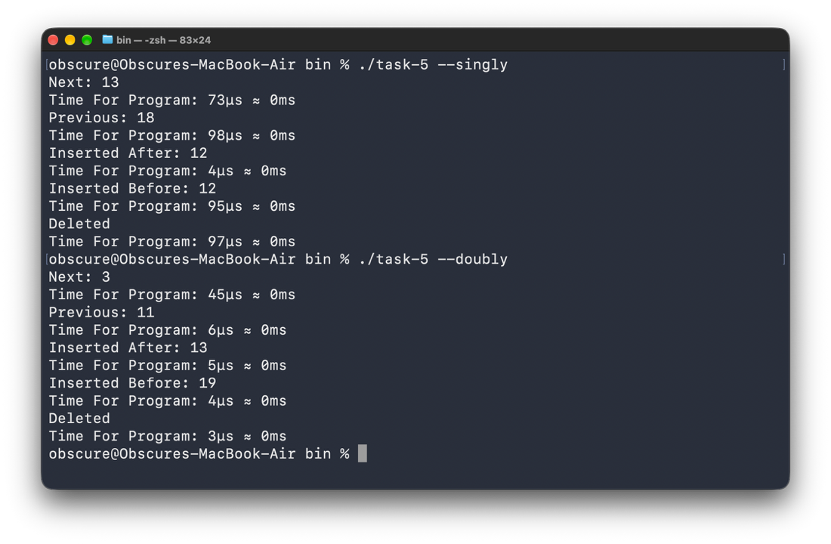
Final Question: The doubly linked list trades the additional memory of storing the previous pointer to get the previous node in O(1) time complexity.
Examples:
- Moving the Previous Node: In singly linked list moving to the previous node requires traversal from the head to that point, while in doubly linked list, we can just use the pointer of that node
- Deleting a Node: To delete a node, the pointer references for previous and last node must be changed, doing this in singly linked list requires traversal from head as discussed, while in doubly linked list, we can use the previous pointers in the node.

